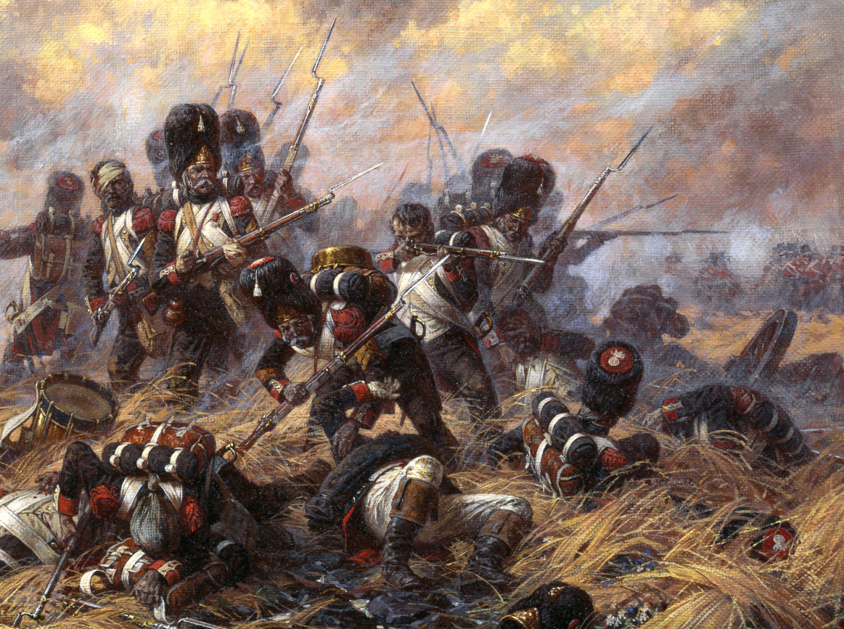
The Profiles:
French Empire

The Profiles: French Empire

Personalities

Napoleon Bonaparte
Points Value: 180 | F | S | D | A | W | C | M | W | F
Napoleon Bonaparte | 4/5+ | 4 | 4 | 1 | 3 | 7 | 4* | 3 | 3

Wargear
Napoleon carries a Sword. He may have the following items at additional cost:
Pistol – 2 pts
Brace of Pistols – 3 pts
Horse – 10 pts

Special Rules
Emperor All French models on the battlefield receive a +1 modifier to their Courage if Napoleon is on the battlefield. All French models within 6” of Napoleon receive a +1 modifier to their Fight Value.
Strategist Napoleon receives 1 free might point per turn. In addition, his Heroic Move and Shoot affect all models within 10”.

Michel Ney
Points Value: 130 | F | S | D | A | W | C | M | W | F
Marshal Ney (General) | 6/4+ | 4 | 4 | 3 | 3 | 7 | 3 | 3 | 3

Wargear
Michel Ney carries a Sword. He may have the following items at additional cost:
Pistol – 2 pts
Brace of Pistols – 3 pts
Horse – 10 pts
Musket – 5 pts
Bayonet – 1 pt

Special Rules
Le brave des braves Michel Ney was one of Napoleon’s greatest Marshals. Whenever Ney expends a point of Might, roll 2D6. If the result is 7 or more, the action will not deplete his store of Might.

Antione Lasalle
Points Value: 130 | F | S | D | A | W | C | M | W | F
Antoine Lasalle  (General) | 6/5+ | 4 | 5 | 3 | 3 | 7 | 3 | 3 | 3

Wargear
Antoine Lasalle carries a Sword. He may have the following items at additional cost:
Horse – 10 pts
Pistol – 2 pts
Brace of Pistols – 3 pts

Special Rules
Tout hussard qui n’est pas mort a trente ans est un jean-foutre! Lasalle’s bravery is legendary. Soldiers are inspired by his presence. If any Officer, NCO, or Private within 8” of Lasalle fails a courage test for ‘Dive for Cover!’ or charging a Terrifying Enemy, they must redo the test.
Hussars Hussars are the fleetest and most audacious of the cavalry. They move 12” instead of 10”.
Charge! When on the charge on horseback, Hussars use their swords almost as lances. They gain a +1 bonus when rolling to wound on the charge, just as a lance does. Note that this does not negate the bonus of spears against cavalry.
Expert Rider 1 is added to any Jump Test or Thrown Rider tests made by this model.

Colonel Gaspard Gourgaud
Points Value: 70 | F | S | D | A | W | C | M | W | F
Gourgaud (Officer) | 4/4+ | 4 | 4 | 1 | 2 | 5 | 2 | 1 | 2

Wargear
Gaspard Gourgaud carries a Sword. He may have the following items at additional cost:
Pistol – 2 pts
Brace of Pistols – 3 pts

Special Rules
First Ordinance Officer Any friendly cannon within 6” of Gourgaud will receive a +1 modifier when rolling on the Scatter and Batter Charts. All howitzers within 6” have their fuses automatically cut to the right length, and their radius of damage is D3+1” instead of D3”.

Aide de Camp
Points Value: 75 | F | S | D | A | W | C | M | W | F
Aide de Camp (Officer) | 4/4+ | 4 | 4 | 2 | 2 | 4 | 2 | 1 | 1

Wargear
An Aide de Camp carries a Sword. He may have the following items at additional cost:
Pistol – 2 pts
Brace of Pistols – 3 pts
Musket – 2 pts
Carbine – 2 pts
Bayonet – 1 pt
Horse – 10 pts

Special Rules
Aide de Camp Aides de Camp are assigned to a specific General at the beginning of the game. They pass all Courage Tests they are required to take as long as that hero is still alive. In addition, any area bonus that the General gives is given out to half the distance by the Aide de camp. For instance, an aide de camp to General Paget would cause all cavalry within 3” to move 12”, and the Duke of Wellington’s aide de camp’s heroic actions would affect all models within 7”.

Fusiliers
Note: If an army should field Early War Fusiliers and Late War Fusiliers, a clear distinction between the two must be made.

Fusilier Captain
Points Value: 55 | F | S | D | A | W | C | M | W | F
Fusilier Captain | 4/5+ | 4 | 4 | 2 | 2 | 5 | 3 | 2 | 2

Wargear
A Line Infantry Captain carries a Sword. He may have the following items at additional cost:
Pistol – 2 pts
Brace of Pistols – 3 pts
Horse – 10 pts

Fusilier Sergeant (Early War)
Points Value: 25 | F | S | D | A | W | C | M | W | F
Fusilier Sergeant | 4/5+ | 4 | 4 | 1 | 1 | 4 | 1 | 1 | 1

wargear
A Fusilier Sergeant is armed with a Sword. He may have the following items at additional cost:
Musket – 2 pts
Pike – 1 pt
Bayonet – 1 pt
Pistol – 1 pts
Brace of Pistols – 2 pts
Banner – 30 pts

Special rules
Disciplinarian Sergeants maintained order on the lines, with commands to kill any man who fled. Should any soldier fleeing because of a failed courage test pass within 3” of the Sergeant, the model must stop, and the Sergeant will inflict one automatic Strength 4 hit on the model. If this does not kill the model, he may continue to flee the board. If it does kill him, all NCOs and Soldiers within 10” of the killed model automatically pass all Courage tests for the remainder of the turn.

Fusilier Sergeant (Late War)
Points Value: 24 | F | S | D | A | W | C | M | W | F
Fusilier Sergeant | 3/5+ | 4 | 4 | 1 | 1 | 4 | 1 | 1 | 1

wargear
A Fusilier Sergeant is armed with a Sword. He may have the following items at additional cost:
Musket – 2 pts
Pike – 1 pt
Bayonet – 1 pt
Pistol – 1 pts
Brace of Pistols – 2 pts
Banner – 30 pts

Special Rules
Disciplinarian See Fusilier Sergeant (Early War)

Fusilier (Early war)
Points Value: 8 | F | S | D | A | W | C
Fusilier | 3/5+ | 3 | 3 | 1 | 1 | 2

wargear
A Fusilier is armed with a Short Sword, Musket and bayonet. He may have the following items at additional cost:
Drum or similar instrument – 25 pts
Banner – 30 pts

Fusilier (Late war)
Points Value: 7 | F | S | D | A | W | C
Fusilier | 2/5+ | 3 | 3 | 1 | 1 | 2

wargear
A Fusilier is armed with a Musket and Bayonet. He may have the following items at additional cost:
Drum or similar instrument – 25 pts
Banner – 30 pts

Voltigeurs

Voltigeur Captain
Points Value: 60 | F | S | D | A | W | C | M | W | F
Light Infantry Captain | 5/4+ | 4 | 4 | 2 | 2 | 5 | 2 | 2 | 2

Wargear
A Voltigeur Captain carries a Sword. He may have the following items at additional cost:
Pistol – 2 pts
Brace of Pistols – 3 pt

Voltigeur Sergeant
Points Value: 26 | F | S | D | A | W | C | M | W | F
Light Infantry Sergeant | 4/4+ | 4 | 4 | 1 | 1 | 4 | 1 | 1 | 1

Wargear
A Voltigeur Sergeant carries a Sword. He may have the following items at additional cost:
Pistol – 1 pts
Brace of Pistols – 2 pts
Musket – 2 pts

Special rules
Only an NCO The range of a Sergeant’s “Stand Fast!” is 3”.

Voltigeur
Points Value: 11 | F | S | D | A | W | C
Voltigeur | 4/4+ | 3 | 3 | 1 | 1 | 3

wargear
A Voltigeur is armed with a Short Sword, Musket and Bayonet. He may have the following items at additional cost:
Bugle or similar instrument – 25 pts

Grenadiers

Grenadier Captain
Points Value: 65 | F | S | D | A | W | C | M | W | F
Grenadier Captain | 5/4+ | 4 | 5 | 2 | 2 | 5 | 3 | 1 | 2
A Grenadier Captain carries a Sword. He may have the following items at additional cost:
Pistol – 2 pts
Brace of Pistols – 3 pts
Horse – 10 pts

Grenadier Sergeant
Points Value: 26 | F | S | D | A | W | C | M | W | F
Grenadier Sergeant | 4/4+ | 4 | 4 | 1 | 1 | 4 | 1 | 1 | 1

Wargear
A Grenadier Sergeant carries a Sword. He may have the following items at additional cost:
Pike – 1 pt
Musket – 2 pts
Bayonet – 1 pt
Pistol – 1 pt
Brace of pistols – 2 pts
Banner – 30 pts

Special rules
Only an NCO The range of a Sergeant’s “Stand Fast!” is 3”.
Disciplinarian Sergeants maintained order within the ranks of conscripts, with commands to kill any man who fled. Should any soldier fleeing because of a failed courage test pass within 3” of the Sergeant, the model must stop, and the Sergeant will inflict one automatic Strength 4 hit on the model. If this does not kill the model, he may continue to flee the board. If it does kill him, all NCOs and Soldiers within 10” of the killed model automatically pass all Courage tests for the remainder of the turn.

Grenadier
Points Value: 12 | F | S | D | A | W | C
Grenadier | 3/4+ | 4 | 4 | 1 | 1 | 3

wargear
A Grenadier is armed with a Musket and Bayonet. He may have the following items at additional cost:
Bugle or similar instrument – 25 pts
Banner – 30 pts

Imperial Guard: Grenadiers

Old Guard Grenadier Captain
Points Value: 78 | F | S | D | A | W | C | M | W | F
Grenadier Captain | 6/4+ | 4 | 5 | 2 | 2 | 5 | 3 | 2 | 2
A Grenadier Captain carries a Sword. He may have the following items at additional cost:
Pistol – 2 pts
Brace of Pistols – 3 pts
Horse – 10 pts

Special rules
Terror The Old Guard are among the most experienced of Napoleon’s troops, notwithstanding the fact that they are also the among the largest. Napoleon rarely sends this elite into combat but when he does, they are a sight to behold. They cause Terror.
Imperial Guard If Napoleon is on the battlefield, the Imperial Guard will automatically pass all courage tests.

Old Guard Grenadier Sergeant
Points Value: 28 | F | S | D | A | W | C | M | W | F
Old Guard Grenadier Sergeant | 4/4+ | 4 | 5 | 1 | 1 | 4 | 1 | 1 | 1

Wargear
An Old Guard Grenadier Sergeant carries a Sword. He may have the following items at additional cost:
Pistol – 1 pts
Brace of Pistols – 2 pts
Musket – 2 pts
Pike – 1 pt
Banner – 30 pts

Special rules
Disciplinarian Sergeants maintained order within the ranks of conscripts, with commands to kill any man who fled. Should any soldier fleeing because of a failed courage test pass within 3” of the Sergeant, the model must stop, and the Sergeant will inflict one automatic Strength 4 hit on the model. If this does not kill the model, he may continue to flee the board. If it does kill him, all NCOs and Soldiers within 10” of the killed model automatically pass all Courage tests for the remainder of the turn.
Terror The Old Guard are among the most experienced of Napoleon’s troops, notwithstanding the fact that they are also the among the largest. Napoleon rarely sends this elite into combat but when he does, they are a sight to behold. They cause Terror.
Imperial Guard If Napoleon is on the battlefield, the Imperial Guard will automatically pass all courage tests.

Old Guard Grenadier
Points Value: 15 | F | S | D | A | W | C
Old Guard Grenadier | 4/4+ | 4 | 4 | 1 | 1 | 4

wargear
An Old Guard Grenadier is armed with a Short Sword, Musket and bayonet. He may have the following items at additional cost:
Bugle or similar instrument – 25 pts
Banner – 30 pts

Special Rules
Terror The Old Guard are among the most experienced of Napoleon’s troops, notwithstanding the fact that they are also the among the largest. Napoleon rarely sends this elite into combat but when he does, they are a sight to behold. They cause Terror.
Imperial Guard If Napoleon is on the battlefield, the Imperial Guard will automatically pass all courage tests.

Imperial Guard: Chasseurs a Pied

Old Guard Chasseur Captain
Points Value: 65 | F | S | D | A | W | C | M | W | F
Old Guard Chasseur  Captain | 5/4+ | 4 | 5 | 2 | 2 | 5 | 2 | 2 | 2

Wargear
An Old Guard Chasseur a Pied Captain carries a Sword. He may have the following items at additional cost:
Horse – 6 pts
Pistol – 2 pts
Brace of Pistols – 3 pts

Special rules
Imperial Guard If Napoleon is on the battlefield, the Imperial Guard will automatically pass all courage tests.

Old Guard Chasseur Sergeant
Points Value: 26 | F | S | D | A | W | C | M | W | F
Old Guard Chasseur  Sergeant | 4/4+ | 4 | 4 | 1 | 1 | 4 | 1 | 1 | 1

Wargear
An Old Guard Chasseur Sergeant carries a Sword. He may have the following items at additional cost:
Horse – 6 pts
Pistol – 1 pts
Brace of Pistols – 2 pts
Musket – 2 pts
Pike – 1 pt
Banner – 30 pts

Special rules
Imperial Guard If Napoleon is on the battlefield, the Imperial Guard will automatically pass all courage tests.

Old Guard Chasseur
Points Value: 10 | F | S | D | A | W | C
Old Guard Chasseur a Pied | 4/4+ | 3 | 4 | 1 | 1 | 4

wargear
An Old Guard Chasseur is armed with a Sword. He may have the following items at additional cost:
Musket – 2 pts
Bayonet – 1 pt
Horse – 5 pts
Bugle or similar instrument – 25 pts
Banner – 30 pts

Special Rules
Imperial Guard If Napoleon is on the battlefield, the Imperial Guard will automatically pass all courage tests.

Imperial Guard: Middle Guard

Middle Guard Captain
Points Value: 65 | F | S | D | A | W | C | M | W | F
Middle Guard  Captain | 5/4+ | 4 | 5 | 2 | 2 | 5 | 3 | 1 | 2

Wargear
A Middle Guard Captain carries a Sword. He may have the following items at additional cost:
Pistol – 2 pts
Brace of Pistols – 3 pts

Special rules
Imperial Guard If Napoleon is on the battlefield, the Imperial Guard will automatically pass all courage tests.

Middle Guard Sergeant
Points Value: 26 | F | S | D | A | W | C | M | W | F
Middle Guard Sergeant | 4/4+ | 4 | 4 | 1 | 1 | 4 | 1 | 1 | 1

Wargear
A Middle Guard Sergeant carries a Sword. He may have the following items at additional cost:
Pistol – 1 pts
Brace of Pistols – 2 pts
Musket – 2 pts
Pike – 1 pt
Banner – 30 pts

Special rules
Disciplinarian Sergeants maintain order within the ranks of conscripts, with commands to kill any man who fled. Should any soldier fleeing because of a failed courage test pass within 3” of the Sergeant, the model must stop, and the Sergeant will inflict one automatic Strength 4 hit on the model. If this does not kill the model, he may continue to flee the board. If it does kill him, all NCOs and Soldiers within 10” of the killed model automatically pass all Courage tests for the remainder of the turn.
Imperial Guard If Napoleon is on the battlefield, the Imperial Guard will automatically pass all courage tests.

Middle Guard
Points Value: 12 | F | S | D | A | W | C
Middle Guard | 4/4+ | 3 | 4 | 1 | 1 | 3

wargear
A Middle Guard is armed with a Short Sword, Musket and Bayonet. He may have the following items at additional cost:
Bugle or similar instrument – 25 pts
Banner – 30 pts

Special Rules
Imperial Guard If Napoleon is on the battlefield, the Imperial Guard will automatically pass all courage tests.

Imperial Guard: Young Guard

Young Guard Captain
Points Value: 50 | F | S | D | A | W | C | M | W | F
Young Guard  Captain | 4/4+ | 4 | 5 | 2 | 2 | 5 | 2 | 1 | 2

Wargear
A Young Guard Captain carries a Sword. He may have the following items at additional cost:
Pistol – 2 pts
Brace of Pistols – 3 pts

Special rules
Imperial Guard If Napoleon is on the battlefield, the Imperial Guard will automatically pass all courage tests.

Young Guard Sergeant
Points Value: 26 | F | S | D | A | W | C | M | W | F
Young Guard Sergeant | 4/4+ | 4 | 4 | 1 | 1 | 4 | 1 | 1 | 1

Wargear
A Young Guard Sergeant carries a Sword. He may have the following items at additional cost:
Pistol – 1 pts
Brace of Pistols – 2 pts
Musket – 2 pts
Pike – 1 pt
Banner – 30 pts

Special rules
Disciplinarian Sergeants maintain order within the ranks of conscripts, with commands to kill any man who fled. Should any soldier fleeing because of a failed courage test pass within 3” of the Sergeant, the model must stop, and the Sergeant will inflict one automatic Strength 4 hit on the model. If this does not kill the model, he may continue to flee the board. If it does kill him, all NCOs and Soldiers within 10” of the killed model automatically pass all Courage tests for the remainder of the turn.
Imperial Guard If Napoleon is on the battlefield, the Imperial Guard will automatically pass all courage tests.

Young Guard
Points Value: 10 | F | S | D | A | W | C
Young Guard | 3/4+ | 3 | 3 | 1 | 1 | 3

wargear
A Young Guard is armed with a Short Sword, Musket and Bayonet. He may have the following items at additional cost:
Bugle or similar instrument – 25 pts
Banner – 30 pts

Special Rules
Imperial Guard If Napoleon is on the battlefield, the Imperial Guard will automatically pass all courage tests.

Cuirassiers

Cuirassier Captain
Points Value: 75 | F | S | D | A | W | C | M | W | F
Cuirassier  Captain | 5/5+ | 4 | 4 | 2 | 2 | 6 | 3 | 2 | 2

Wargear
A Cuirassier Captain carries a Sword and rides a horse. He may have the following items at additional cost:
Pistol – 2 pts
Heavy Armour – 10 pts

Cuirassier Sergeant
Points Value: 31 | F | S | D | A | W | C | M | W | F
Cuirassier Sergeant | 4/5+ | 4 | 4 | 1 | 1 | 4 | 1 | 1 | 1
A Cuirassier Sergeant carries a Sword and rides a Horse. He may have the following items at additional cost:
Banner – 30 pts
Carbine – 2 pts
Pistol – 1 pt
Heavy Armour – 2 pts

Cuirassier
Points Value: 13 | F | S | D | A | W | C
Cuirassier | 4/5+ | 3 | 3 | 1 | 1 | 4

wargear
A Cuirassier is armed with a Sword and Horse. He may have the following items at additional cost:
Carbine – 2 pts
Pistol – 1 pt
Heavy Armour – 2 pts
Bugle or similar instrument – 25 pts
Banner – 30 pts

Dragoons

Dragoon Captain
Points Value: 65 | F | S | D | A | W | C | M | W | F
Dragoon  Captain | 5/4+ | 4 | 5 | 2 | 2 | 5 | 2 | 2 | 2

Wargear
A Dragoon Captain carries a Sword. He may have the following items at additional cost:
Pistol – 2 pts
Brace of Pistols – 3 pts
Horse – 10 pts

Special Rules
Not Foot Soldiers! All Dragoons suffer a -1 Courage penalty when on foot.

Dragoon Sergeant
Points Value: 25 | F | S | D | A | W | C | M | W | F
Dragoon Sergeant | 4/5+ | 4 | 4 | 1 | 1 | 4 | 1 | 1 | 1
A Dragoon Sergeant carries a Sword. He may have the following items at additional cost:
Banner – 30 pts
Carbine – 2 pts
Musket – 2 pts
Bayonet – 1 pt
Pistol – 1 pt
Horse – 6 pts

Special Rules
Not Foot Soldiers! All Dragoons suffer a -1 Courage penalty when on foot.

Dragoon
Points Value: 12 | F | S | D | A | W | C
Dragoon | 4/4+ | 3 | 4 | 1 | 1 | 4

wargear
A Dragoon is armed with a Sword and Carbine. He may have the following items at additional cost:
Horse – 5 pts
Upgrade Carbine to Musket – free
Bayonet – 1 pt
Bugle or similar instrument – 25 pts
Banner – 30 pts

Special Rules
Not Foot Soldiers! All Dragoons suffer a -1 Courage penalty when on foot.

Hussars

Hussar Captain
Points Value: 100 | F | S | D | A | W | C | M | W | F
Hussar  Captain | 6/5+ | 4 | 5 | 2 | 2 | 6 | 3 | 3 | 2

Wargear
A Hussar Captain carries a Sword and rides a Horse. He may have the following items at additional cost:
Pistol – 2 pts

Special Rules
Hussars Hussars are the fleetest and most audacious of the cavalry. They move 12” instead of 10”.
Charge! When on the charge on horseback, Hussars use their swords almost as lances. They gain a +1 bonus when rolling to wound on the charge, just as a lance does. Note that this does not negate the bonus of spears against cavalry.
Expert Rider 1 is added to any Jump Test or Thrown Rider tests made by this model.

Hussar Sergeant
Points Value: 38 | F | S | D | A | W | C | M | W | F
Hussar Sergeant | 5/5+ | 4 | 5 | 1 | 1 | 5 | 2 | 1 | 1
A Hussar Sergeant carries a Sword and rides a Horse. He may have the following items at additional cost:
Carbine – 2 pts
Pistol – 1 pt
Bugle or similar instrument – 25 pts
Banner – 30 pts

Special Rules
Hussars Hussars are the fleetest and most audacious of the cavalry. They move 12” instead of 10”.
Charge! When on the charge on horseback, Hussars use their swords almost as lances. They gain a +1 bonus when rolling to wound on the charge, just as a lance does. Note that this does not negate the bonus of spears against cavalry.
Expert Rider 1 is added to any Jump Test or Thrown Rider tests made by this model.

Hussar
Points Value: 18 | F | S | D | A | W | C
Hussar | 5/5+ | 4 | 4 | 1 | 1 | 5

wargear
A Hussar is armed with a Sword and Horse. He may have the following items at additional cost:
Carbine – 2 pts
Pistol – 1 pt
Bugle or similar instrument – 25 pts
Banner – 30 pts

Special Rules
Hussars Hussars are the fleetest and most audacious of the cavalry. They move 12” instead of 10”.
Charge! When on the charge on horseback, Hussars use their swords almost as lances. They gain a +1 bonus when rolling to wound on the charge, just as a lance does. Note that this does not negate the bonus of spears against cavalry.
Expert Rider 1 is added to any Jump Test or Thrown Rider tests made by this model.

Lancers

Lancer Captain
Points Value: 70 | F | S | D | A | W | C | M | W | F
Lancer  Captain | 5/5+ | 4 | 4 | 2 | 2 | 5 | 3 | 2 | 2

Wargear
A Lancer Captain carries a Sword and rides a Horse. He may have the following items at additional cost:
Pistol – 2 pts
Lance – 3 pts

Lancer Sergeant
Points Value: 31 | F | S | D | A | W | C | M | W | F
Lancer Sergeant | 5/5+ | 4 | 4 | 1 | 1 | 4 | 1 | 1 | 1
A Lancer Sergeant carries a Sword and rides a Horse. He may have the following items at additional cost:
Lance – 1 pt
Carbine – 2 pts
Pistol – 1 pt
Banner – 30 pts

Lancer
Points Value: 12 | F | S | D | A | W | C
Lancer | 4/5+ | 3 | 3 | 1 | 1 | 3

wargear
A Lancer is armed with a Sword and Horse. He may have the following items at additional cost:
Lance – 1 pt
Carbine – 2 pts
Pistol – 1 pt
Bugle or similar instrument – 25 pts
Banner – 30 pts

Chasseurs à Cheval

Chasseur à Cheval Captain
Points Value: 77 | F | S | D | A | W | C | M | W | F
Chasseur à Cheval Captain | 6/5+ | 4 | 4 | 2 | 2 | 5 | 3 | 2 | 2

Wargear
A Chasseur à Cheval Captain carries a Sword and rides a Horse. He may have the following items at additional cost:
Pistol – 2 pts

Special Rules
Charge! When on the charge on horseback, Chasseurs use their swords as lances. They gain a +1 bonus when rolling to wound on the charge, just as a lance does. Note that this does not negate the bonus of spears against cavalry.

Chasseur à Cheval Sergeant
Points Value: 33 | F | S | D | A | W | C | M | W | F
Chasseur à Cheval Sergeant | 5/5+ | 4 | 4 | 1 | 1 | 5 | 1 | 1 | 1
A Chasseur à Cheval Sergeant carries a Sword and rides a Horse. He may have the following items at additional cost:
Carbine – 2 pts
Pistol – 1 pt
Banner – 30 pts

Special Rules
Charge! When on the charge on horseback, Chasseurs use their swords as lances. They gain a +1 bonus when rolling to wound on the charge, just as a lance does. Note that this does not negate the bonus of spears against cavalry.

Chasseur à Cheval
Points Value: 14 | F | S | D | A | W | C
Chasseur | 4/5+ | 3 | 3 | 1 | 1 | 4

wargear
A Chasseur a Cheval is armed with a Sword and Horse. He may have the following items at additional cost:
Carbine – 2 pts
Pistol – 1 pt
Bugle or similar instrument – 25 pts
Banner – 30 pts

Special Rules
Charge! When on the charge on horseback, Chasseurs use their swords as lances. They gain a +1 bonus when rolling to wound on the charge, just as a lance does. Note that this does not negate the bonus of spears against cavalry.

Sappers

Sapper
Points Value: 11 | F | S | D | A | W | C
Household Cavalry | 4/5+ | 4 | 4 | 1 | 1 | 3

wargear
A Sapper is armed with a two handed axe. He may have the following items at additional cost:
Musket – 2 pts
Shovel – 1 pt
Shovel A model armed with a shovel may create small defensive embankments. These are 1” wide, and approximately ¼” tall, and about ½” wide. If a sapper remains stationary for 2 turns, he may create one of these. They provide an “In the way” roll for troops lying prone behind them.

Special Rules
Brute Strength Sappers do not receive a -1 penalty for determining the winner of a fight.

Cannon

4 Pdr Cannon
Points Value: 50 | (Strength) | Defence | Batter Points
Cannon | 8-7 | 9 | 3

 | F | S | D | A | W | C
Crewman | 3/5+ | 3 | 3 | 1 | 1 | 2

A 3 Pdr Cannon consists of a Cannon and 3 Crewmen armed with swords. Extra crew can be bought for 6 pts.

Upgrades
Grape Shot- 7 pts
Canister Shot -5 pts
Superior Construction – 10pts
Siege Veterans – 10pts
Master Gunner – 60pts
Limber Team – 25 pts

6 Pdr Cannon
Points Value: 60 | (Strength) | Defence | Batter Points
Cannon | 9-8 | 9 | 3

 | F | S | D | A | W | C
Crewman | 3/5+ | 3 | 3 | 1 | 1 | 2

A 6 Pdr Cannon consists of a Cannon and 4 Crewmen armed with swords. Extra crew can be bought for 6 pts.

Upgrades
Grape Shot- 9 pts
Canister Shot -7 pts
Superior Construction – 10 pts
Siege Veterans – 10 pts
Master Gunner – 60 pts
Limber Team – 40 pts

8 Pdr Cannon
Points Value: 70 | (Strength) | Defence | Batter Points
Cannon | 10-9 | 10 | 3

 | F | S | D | A | W | C
Crewman | 3/5+ | 3 | 3 | 1 | 1 | 2

A 9 Pdr Cannon consists of a Cannon and 4 Crewmen armed with swords. Extra crew can be bought for 6 pts.

Upgrades
Grape Shot- 11 pts
Canister Shot - 10 pts
Superior Construction – 13 pts
Siege Veterans – 13 pts
Master Gunner – 60 pts
Limber Team – 50 pts

12 Pdr Cannon
Points Value: 80 | (Strength) | Defence | Batter Points
Cannon | 11-10 | 10 | 4

 | F | S | D | A | W | C
Crewman | 3/5+ | 3 | 3 | 1 | 1 | 2

A 12 Pdr Cannon consists of a Cannon and 5 Crewmen armed with swords. Extra crew can be bought for 6 pts.

Upgrades
Grape Shot- 13 pts
Canister Shot - 13 pts
Superior Construction – 15 pts
Siege Veterans – 15 pts
Master Gunner – 60 pts
Limber Team – 60 pts

18 Pdr Cannon
Points Value: 105 | (Strength) | Defence | Batter Points
Cannon | 13-12 | 10 | 4

 | F | S | D | A | W | C
Crewman | 3/5+ | 3 | 3 | 1 | 1 | 2

An 18 Pdr Cannon consists of a Cannon and 5 Crewmen armed with swords. Extra crew can be bought for 6 pts.

Upgrades
Grape Shot- 15 pts
Canister Shot - 15 pts
Superior Construction – 18 pts
Siege Veterans – 18 pts
Master Gunner – 60 pts
Limber Team – 70 pts

24 Pdr Cannon
Points Value: 125 | (Strength) | Defence | Batter Points
Cannon | 15-14 | 10 | 5

 | F | S | D | A | W | C
Crewman | 3/5+ | 3 | 3 | 1 | 1 | 2

A 24 Pdr Cannon consists of a Cannon and 6 Crewmen armed with swords. Extra crew can be bought for 6 pts.

Upgrades
Grape Shot- 18 pts
Canister Shot - 18 pts
Superior Construction – 20 pts
Siege Veterans – 20 pts
Master Gunner – 60 pts
Limber Team – 80 pts

6” Howitzer
Points Value: 115 | (Strength) | Defence | Batter Points
Howitzer | 12 | 10 | 3

 | F | S | D | A | W | C
Crewman | 3/5+ | 3 | 3 | 1 | 1 | 2

A 6” Howitzer consists of a Cannon and 4 Crewmen armed with swords. Extra crew can be bought for 6 pts.

Upgrades
Grape Shot – 10 pts
Canister Shot – 10 pts
Superior Construction – 15 pts
Master Gunner – 60 pts
Limber Team – 60 pts

The Profiles:
Russian Empire

The Profiles: Russian Empire

Cossacks

Cossack Captain
Points Value: 80 | F | S | D | A | W | C | M | W | F
Cossack  Captain | 5/4+ | 4 | 4 | 2 | 2 | 6 | 3 | 3 | 2

Wargear
A Cossack Captain carries a Sword and rides a Horse. He may have the following items at additional cost:
Pistol – 2 pts
Lance – 3 pts

Special Rules
Skirmishers Cossacks are masters of ambush. They may charge an enemy that they do not have line of sight to, provided he is in range and at least one friendly unit that the Cossack does have line of sight to has a line of sight to the model being charged.

Cossack Sergeant
Points Value: 36 | F | S | D | A | W | C | M | W | F
Cossack Sergeant | 4/4+ | 4 | 4 | 1 | 1 | 5 | 1 | 1 | 2
A Cossack Sergeant carries a Sword and rides a Horse. He may have the following items at additional cost:
Lance – 1 pt
Carbine – 2 pt
Pistol – 1 pt
Bow – 2 pts
Banner – 30 pts

Special Rules
Skirmishers See Cossack Captain.

Cossack
Points Value: 13 | F | S | D | A | W | C
Cossack | 3/4+ | 3 | 3 | 1 | 1 | 4

wargear
A Cossack is armed with a Sword and a Horse. He may have the following equipment at additional cost:
Lance – 1 pt
Carbine – 2 pt
Pistol – 1 pt
Bow – 2 pts
Bugle or similar instrument – 25 pts
Banner – 30 pts

Special Rules
Skirmishers See Cossack Captain.

Sappers

Sapper
Points Value: 11 | F | S | D | A | W | C
Household Cavalry | 4/5+ | 4 | 4 | 1 | 1 | 3

wargear
A Sapper is armed with a two handed axe. He may have the following items at additional cost:
Musket – 2 pts
Shovel – 1 pt
Shovel A model armed with a shovel may create small defensive embankments. These are 1” wide, and approximately ¼” tall, and about ½” wide. If a sapper remains stationary for 2 turns, he may create one of these. They provide an “In the way” roll for troops lying prone behind them.

Special Rules
Brute Strength Sappers do not receive a -1 penalty for determining the winner of a fight.

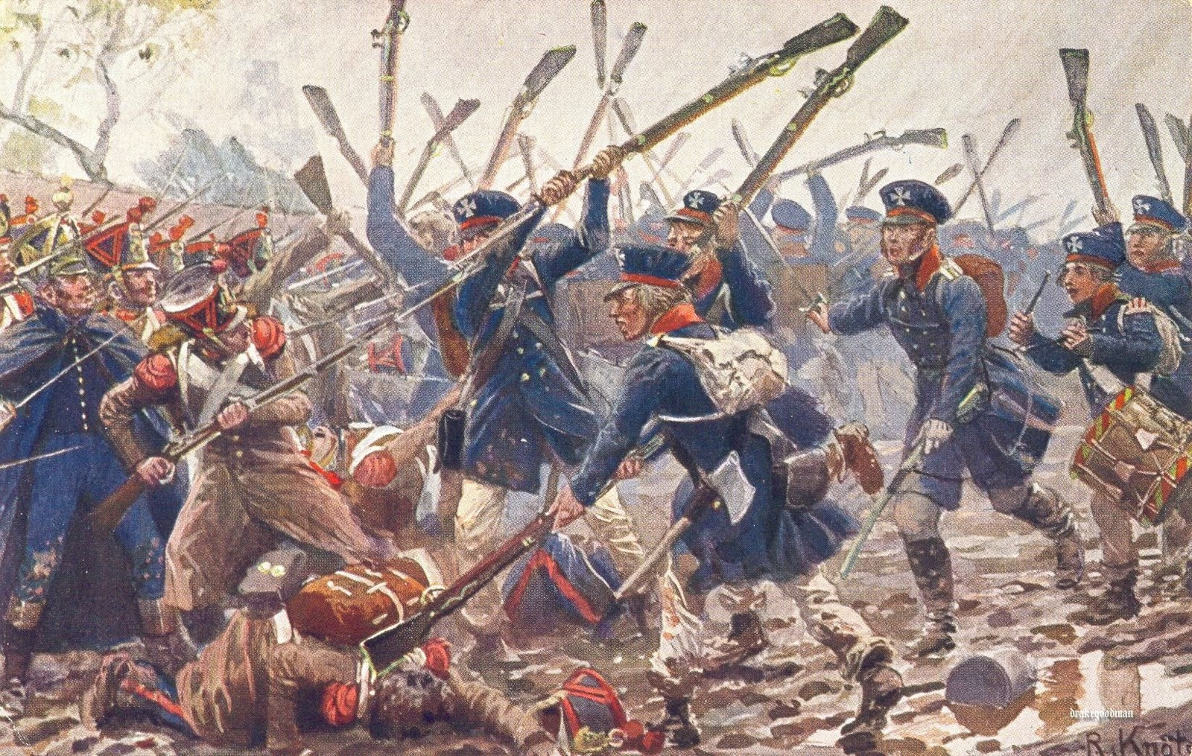
The Profiles:
Kingdom of Prussia

The Profiles: Kingdom of Prussia

Landwehr

Landwehr
Points Value: 5 | F | S | D | A | W | C
Landwehr | 2/5+ | 3 | 3 | 1 | 1 | 3

wargear
A Landwehr is armed with a dagger. He may have the following equipment at additional cost:
Hand weapon – free
Two handed weapon - free
Pike – 1 pt
Musket – 2 pt
Bayonet – 1 pt
Drum or similar instrument – 25 pts
Banner – 25 pts

Sappers

Sapper
Points Value: 11 | F | S | D | A | W | C
Household Cavalry | 4/5+ | 4 | 4 | 1 | 1 | 3

wargear
A Sapper is armed with a two handed axe. He may have the following items at additional cost:
Musket – 2 pts
Shovel – 1 pt
Shovel A model armed with a shovel may create small defensive embankments. These are 1” wide, and approximately ¼” tall, and about ½” wide. If a sapper remains stationary for 2 turns, he may create one of these. They provide an “In the way” roll for troops lying prone behind them.

Special Rules
Brute Strength Sappers do not receive a -1 penalty for determining the winner of a fight.

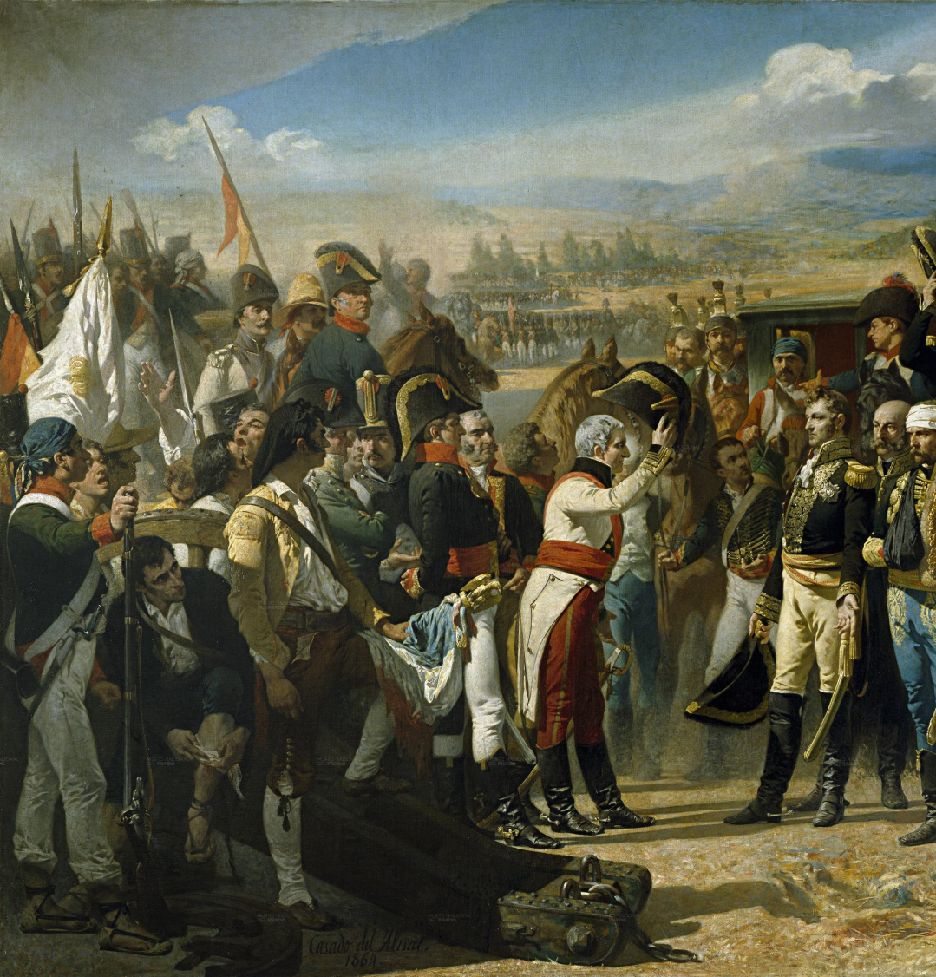
The Profiles:
spain

The Profiles: Spain

Line Infantry

Line Infantry
Points Value: 6 | F | S | D | A | W | C
Line Infantry | 2/5+ | 3 | 3 | 1 | 1 | 1

wargear
A Line Infantry is armed with a Musket and Bayonet. He may have the following items at additional cost:
Drum or similar instrument – 25 pts
Banner – 25 pts

Light Infantry

Light Infantry
Points Value: 7 | F | S | D | A | W | C
Light Infantry | 2/4+ | 3 | 3 | 1 | 1 | 2

Wargear
A Light Infantry is armed with a Musket and bayonet. He may have the following items at additional cost:
Bugle or similar instrument – 25 pts

Grenadiers

Grenadier
Points Value: 10 | F | S | D | A | W | C
Grenadier | 3/5+ | 4 | 4 | 1 | 1 | 3

wargear
A Grenadier is armed with a Musket and Bayonet. He may have the following items at additional cost:
Drum or similar instrument – 25 pts
Banner – 25 pts

Guerillas

Guerrilla
Points Value: 7 | F | S | D | A | W | C
Guerrilla | 3/5+ | 3 | 4 | 1 | 1 | 3

wargear
A Guerrilla is armed with a hand weapon. He may have the following items at additional cost:
Bugle or similar instrument – 25 pts
Two handed weapon – free
Musket – 2 pts
Bayonet – 1 pt
Pike – 1 pt
Rifle – 6 pts
Horse – 5 pts
Carbine – 2 pts
Blunderbuss – 3 pts
Volley Gun – 4 pts
Lance – 1 pt
Grenades – 3 pts

Sappers

Sapper
Points Value: 11 | F | S | D | A | W | C
Household Cavalry | 4/5+ | 4 | 4 | 1 | 1 | 3

wargear
A Sapper is armed with a two handed axe. He may have the following items at additional cost:
Musket – 2 pts
Shovel – 1 pt
Shovel A model armed with a shovel may create small defensive embankments. These are 1” wide, and approximately ¼” tall, and about ½” wide. If a sapper remains stationary for 2 turns, he may create one of these. They provide an “In the way” roll for troops lying prone behind them.

Special Rules
Brute Strength Sappers do not receive a -1 penalty for determining the winner of a fight.

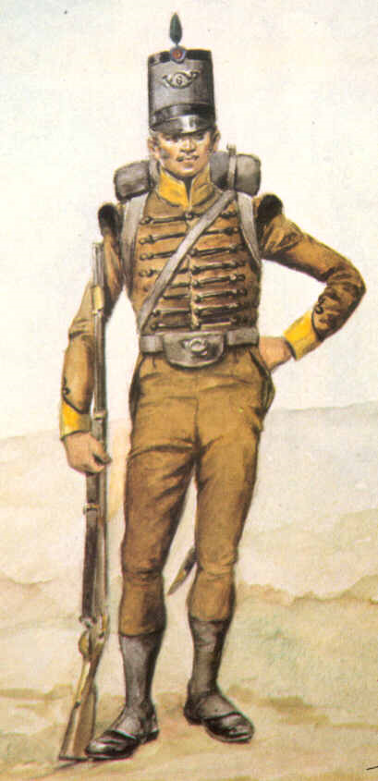
The Profiles:
Portuguese Empire

NOTES
Points Value: | F | S | D | A | W | C
Base Profile | 3/5+ | 3 | 3 | 1 | 1 | 2
Stat increases 1 pt
Points Value: 25 | F | S | D | A | W | C | M | W | F
Base Sergeant | 4/5+ | 4 | 4 | 1 | 1 | 4 | 1 | 1 | 1
Stat increases 1 pt each
Points Value: 50 | F | S | D | A | W | C | M | W | F
Base Captain | 4/5+ | 4 | 4 | 2 | 2 | 5 | 3 | 1 | 2

Cost of weapons
Warriors/NCOs/officers
Bow, carbine, musket - 2/2/5
Rifle 6 pts/6/12
Blunderbuss – 3 pts
Volley Gun – 4 pts
Pistol 1 pt/1/2
Brace of pistols – 2/2/3
Bayonet – 1 pt/1/1
Pike/lance – 1 pt/1/3
Hand weapon - free

